Week 10 - Practical Solutions

Hypothesis Testing in SPSS

Solutions

- By whatever means you feel most appropriate, find the mean of GuessHeight and GuessWeight. These variables are the guesses made as to what the average height and weight of the class would be. 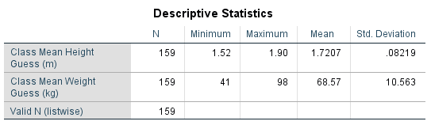
The mean of GuessHeight is 1.7207m and that of GuessWeight is 68.57kg.

Use Analyze – Compare Means – One-Sample T tests to see if the mean of Height is significantly different from the mean guess you just found.
How wrong were they, on average? Were they significantly wrong?
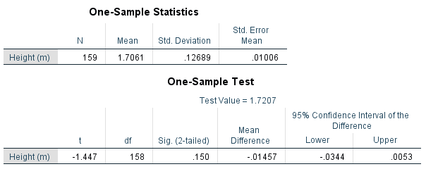
The mean difference shows that their guess was 1.457cm higher than the actual mean.
p=0.150 > 0.05, so their guess is not significantly different from reality.
Try it with Weight in the Test Variable(s): box and the mean of GuessWeight in the Test Value: box. How wrong were they there? Were they significantly wrong?
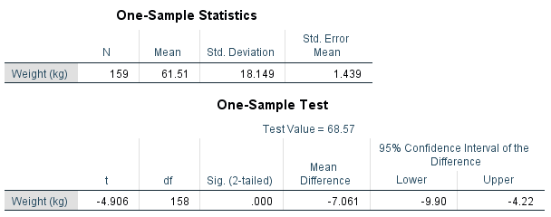This time, their guess was 7.061kg too high, and this was significantly different (as p=0.000 < 0.05) from reality.

- Use Analyze – Compare Means – Paired-Samples T Test to see whether people used their Height as their GuessHeight. Did people guess the mean was higher or lower than their height? Are the variables significantly different?
Repeat your analysis but using Weight and GuessWeight. Are they significantly different?
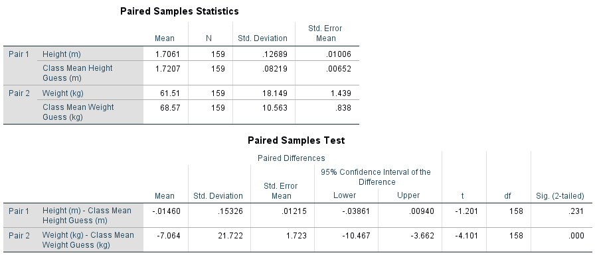
People generally guessed higher than their own Height, and heavier than their own Weight.
This was not significant in the case of Height (p=0.231 > 0.05) but it was in the case of Weight (p=0.000 < 0.05). (Note that this is not the same test as in question 1, hence the different p-value.)

- Use Analyze – Compare Means – Independent-Samples T-Test to test whether the mean Height of the women in the class is the same as the mean Height of the men.
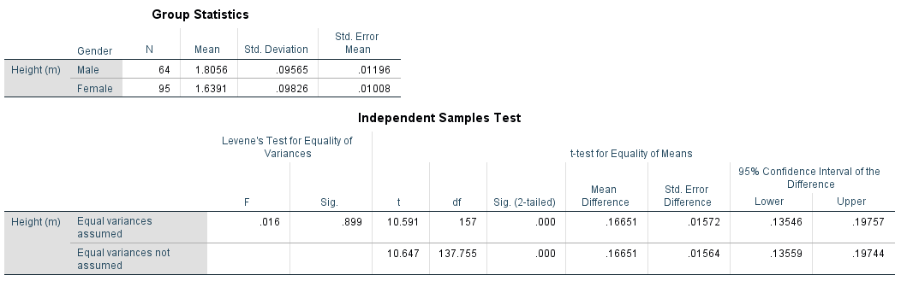
With p=0.899 > 0.05, we find that the variances of the two groups are not significantly different, and so we use the top row t-test. The p-value there is 0.000 < 0.05, so the genders have significantly different Heights.
Try using Breakfast as the Grouping Variable and using Weight instead of Height as the Test Variable. Is there a significant difference in Weight between the groups? Why might this be?
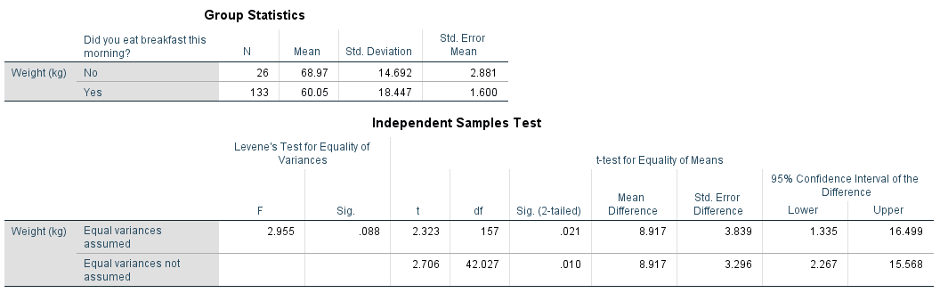
Again, we first check variances; p=0.088 > 0.05, so they are not significantly different, and we use the top row. A p-value of 0.021 < 0.05 shows that the Weights are significantly different, on average. (We recall that this is because the No Breakfast group are mostly men and the Breakfast group are mostly women.)

- Use Analyze – Compare Means – One-Way ANOVA to test whether any College has a significantly different mean Height from any of the other colleges.
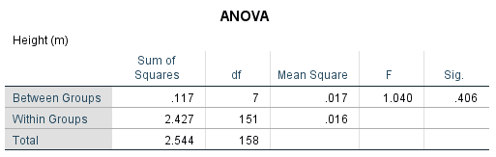
With a p-value of 0.406 > 0.05, no College has a significantly different Height to the rest.
Does any College have a significantly different Weight?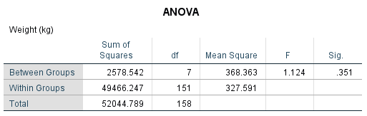
With a p-value of 0.351 > 0.05, no College has a significantly different Weight to the rest.

- Use Analyze – Nonparametric Tests – One-Sample to Automatically compare observed data to hypothesized with the Test Fields Gender and Breakfast.
Are there similar numbers of men and women, or are they significantly different?
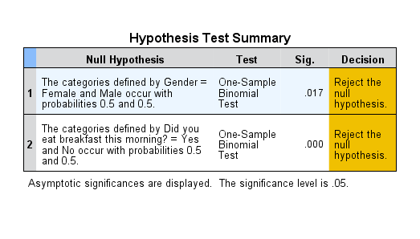
There are significantly different number of men and women, and of those who did and did not have Breakfast.

- Use Analyze – Nonparametric Tests – One-Sample, to Automatically compare observed data to hypothesized to work out whether any of the Colleges has a significantly different number of students in it than the rest.
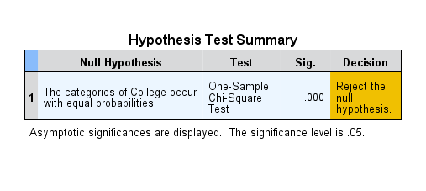
Unsurprisingly, we reject that the Colleges all have the same number of people in them.

- Use the Analyze – Descriptive Statistics – Crosstabs menu option to investigate the relationship between ConfidentWithNumbers and Gender, but add in Chi-square from the Statistics box and Expected from the Cells box. This will carry out a Test of Association (2D) chi-squared test. Where’s the biggest difference between the Count and Expected Count? Is there any significant association between the variables?
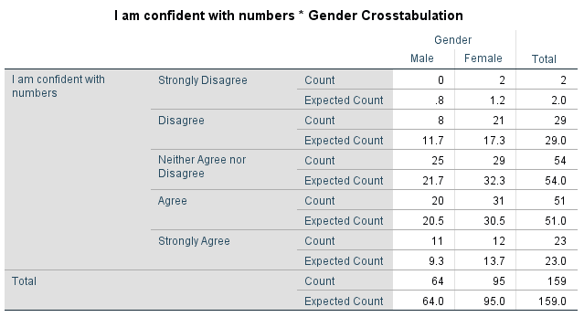The biggest differences are in the Disagree row, and are 3.7. This is most pronounced in the Male column (as the Count is smaller there).
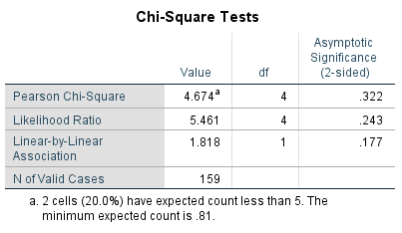
The p-value of the Chi-square test is 0.322 > 0.05, and so we fail to reject the null, and conclude we can’t see any association between these variables.

Additional Questions
- It is possible to do ANOVA tests with just two groups. Try using Analyze – Compare Means – One-Way ANOVA as well as the Independent-Samples T-Test to test whether Height is significantly different between those people that did or did not have Breakfast.
Compare the results (in terms of the Sig. value). What do you notice?
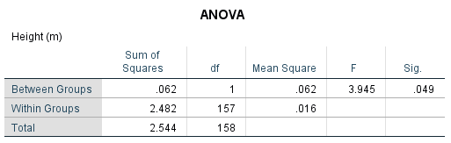
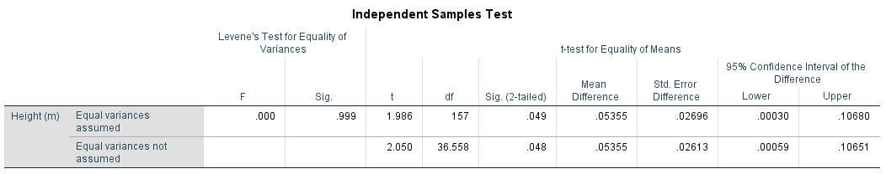
The ANOVA and the “Equal variances assumed” tests have the same p-value. This is not a coincidence.

- t-tests and ANOVA work best when the data are normally distributed. We can check that in several different ways.
Use Analyze – Nonparametric Tests – One Sample to Automatically compare observed data to hypothesized (on the Objective tab) to work out whether Height, Weight, GuessHeight and GuessWeight are normally distributed (you can do them all at once). Because these are continuous (scale) variables, SPSS will automatically compare them to a normal distribution.
Are the Height, Weight, GuessHeight and GuessWeight variables normally distributed?
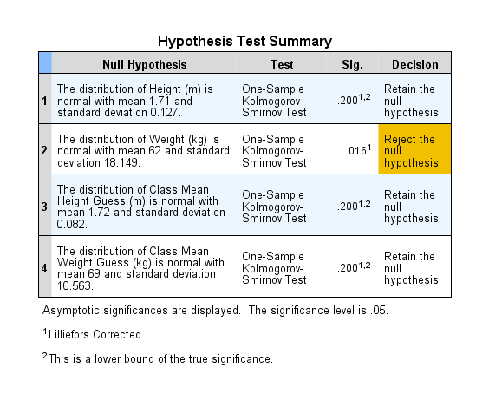Only Weight appears to not be normally distributed (i.e. its distribution is significantly different from the normal distribution with the same mean and standard deviation).

